**Experiment 3.1**

**Student Name: Sahul Kumar Parida UID: 20BCS4919**

**Branch: CSE Section/Group: WM 904/B**

**Semester: 5th Date of Performance: 02/11/22**

**Subject Name: Machine Learning Lab Subject Code: CSP-317**

**1. Aim/Overview of the practical:**

To implement K-means clustering algorithm (cluster some sample data set into disjoint clusters using K-means).

# 2. Task to be done:

**Step 1: Importing the required libraries.**

**Step 2: Creating and Visualizing the data.**

**Step 3: Building the clustering model and calculating the values of the Distortion and Inertia.**

**Step 4: Tabulating and Visualizing the results.**  
a) **Using the different values of Distortion.**

b) **Using the different values of Inertia.**

# 3. Apparatus/Simulator used:

* Jupyter Notebook/Google Collab
* [K-Means Clustering](https://www.geeksforgeeks.org/k-means-clustering-introduction/) - A fundamental step for any unsupervised algorithm is to determine the optimal number of clusters into which the data may be clustered. The **Elbow Method** is one of the most popular methods to determine this optimal value of k.
* We now demonstrate the given method using the K-Means clustering technique using the **Sklearn** library of python.

**4. Code and Output:**

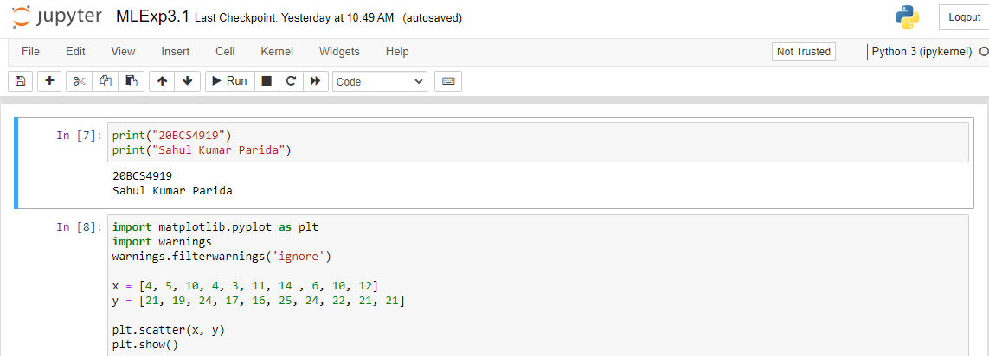

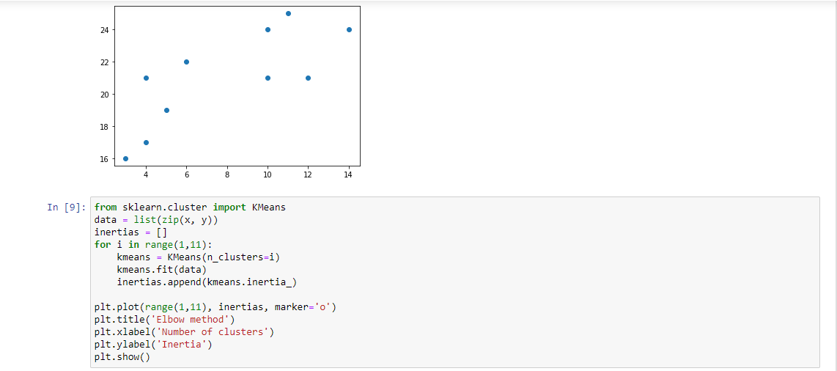

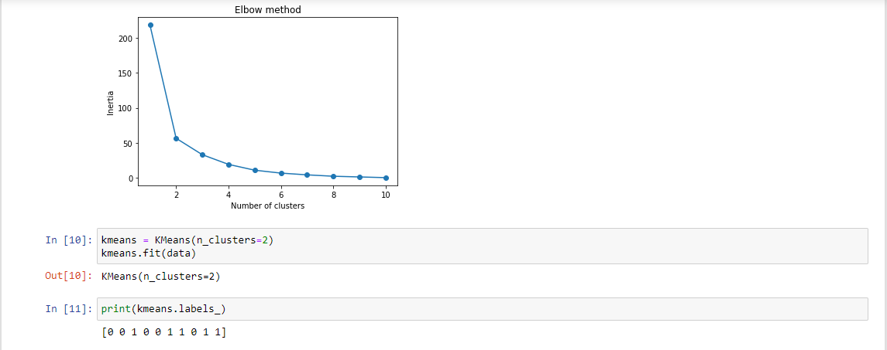

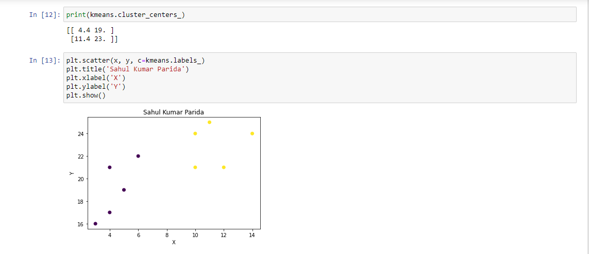

**Learning outcomes (What I have learnt):**

1. Learning about different library/packages of python.
2. Learning about the different methods, that are needed to analyze the given dataset.
3. Learning about different Machine Learning Functions.
4. We learn to split data into training and testing datasets.
5. Implementation of K-Means Clustering.